SESSION 2 - Basic SELECT & FROM Topics: SELECT column1, column2 SELECT *Renaming columns (AS keyword) Comments in SQL Demo: SELECT * FROM employees;

Answer:

What is SELECT?
- SELECT is used to retrieve data from a database table.
- Basic syntax:
SELECT column_name
FROM table_name;

What is FROM?
- FROM tells SQL which table you want to retrieve the data from.
- SELECT → What data do I want?
- FROM → From which table?

SELECT *
- The * means all columns.
- Example:
  - SELECT * FROM employees;
- Returns all columns and all rows.

Selecting One Column
- SELECT city FROM employees;

Using AS to Rename Columns
- The AS keyword gives a temporary name (alias) to a column in the query result.
- Example:
SELECT employee_name AS Name
FROM employees;
- Multiple aliases
SELECT
employee_name AS Name,
department AS Department,
salary AS Monthly_Salary
FROM employees;

Comments in SQL
- Comments are notes written inside SQL code. They are not executed by MySQL.
- Single-line comment
-- Display all employees
SELECT *
FROM employees;
- Multi-line comment
/*
This query displays
all employees
*/
SELECT *
FROM employees;

Demo
CREATE DATABASE Employee_datas
CREATE TABLE employees (
employee_id INT PRIMARY KEY,
employee_name VARCHAR(100),
department VARCHAR(50),
salary DECIMAL(10,2),
city VARCHAR(50)
);
ALTER TABLE employees MODIFY COLUMN employee_id INT AUTO_INCREMENT;
INSERT INTO employees
(employee_name, department, salary, city)
VALUES
('Hitesh', 'IT', 35000, 'Ahmedabad'),
('Rahul', 'HR', 30000, 'Surat'),
('Amit', 'Sales', 28000, 'Rajkot'),
('Priya', 'IT', 42000, 'Vadodara'),
('Neha', 'Finance', 38000, 'Mumbai');
SELECT * FROM employees

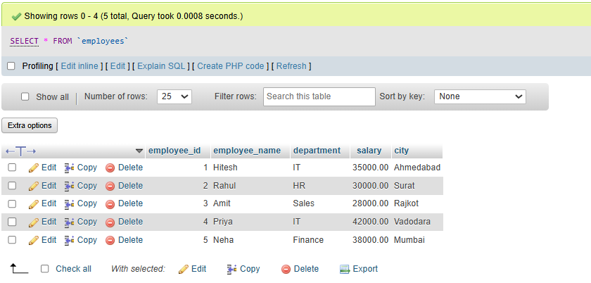
Output

Tasks_01

CREATE TABLE restaurant_data(

restaurant_id int PRIMARY KEY AUTO_INCREMENT,
restaurant_name varchar(50) NOT NULL,
city varchar(50) NOT NULL,
cuisine_type varchar(50) NOT NULL,
rating float,
opening_time time NOT NULL,
closing_time time NOT NULL

)
INSERT INTO restaurant_data
(restaurant_name, city, cuisine_type, rating, opening_time, closing_time)
VALUES
('Spice Garden', 'Ahmedabad', 'Indian', 4.5, '10:00:00', '23:00:00'),
('Pizza Hub', 'Surat', 'Italian', 4.2, '11:00:00', '22:30:00'),
('Dosa Corner', 'Vadodara', 'South Indian', 4.6, '08:00:00', '22:00:00'),
('Burger House', 'Rajkot', 'Fast Food', 4.1, '11:00:00', '23:30:00'),
('The Food Factory', 'Ahmedabad', 'Multi-Cuisine', 4.4, '10:30:00', '23:00:00')
SELECT * FROM restaurant_data;

Output:
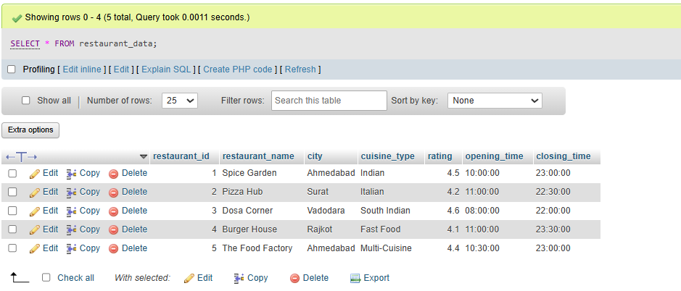

Tasks_02
CREATE TABLE restaurant_data(
restaurant_id int PRIMARY KEY AUTO_INCREMENT,
restaurant_name varchar(50) NOT NULL,
city varchar(50) NOT NULL,
cuisine_type varchar(50) NOT NULL,
rating float,
opening_time time NOT NULL,
closing_time time NOT NULL
)
INSERT INTO restaurant_data
(restaurant_name, city, cuisine_type, rating, opening_time, closing_time)
VALUES
('Spice Garden', 'Ahmedabad', 'Indian', 4.5, '10:00:00', '23:00:00'),
('Pizza Hub', 'Surat', 'Italian', 4.2, '11:00:00', '22:30:00'),
('Dosa Corner', 'Vadodara', 'South Indian', 4.6, '08:00:00', '22:00:00'),
('Burger House', 'Rajkot', 'Fast Food', 4.1, '11:00:00', '23:30:00'),
('The Food Factory', 'Ahmedabad', 'Multi-Cuisine', 4.4, '10:30:00', '23:00:00')
SELECT restaurant_name, city, rating FROM `restaurant_data`

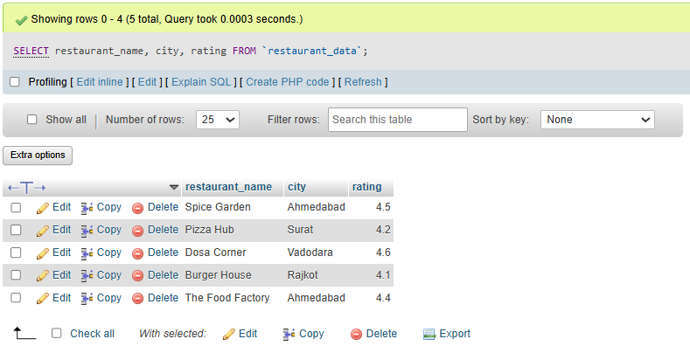
Output

Tasks_03
CREATE DATABASE movies_details
CREATE TABLE movies (
movie_id INT PRIMARY KEY AUTO_INCREMENT,
movie_name VARCHAR(100),
release_year INT,
genre VARCHAR(50),
rating DECIMAL(3,1)
);
INSERT INTO movies (movie_name, release_year, genre, rating)
VALUES
('3 Idiots', 2009, 'Comedy', 8.4),
('Dangal', 2016, 'Sports', 8.3),
('Pathaan', 2023, 'Action', 5.9),
('PK', 2014, 'Comedy', 8.1),
('Drishyam', 2015, 'Thriller', 8.2)
SELECT
movie_name AS Title,
release_year AS `Year Released`
FROM movies;

Output
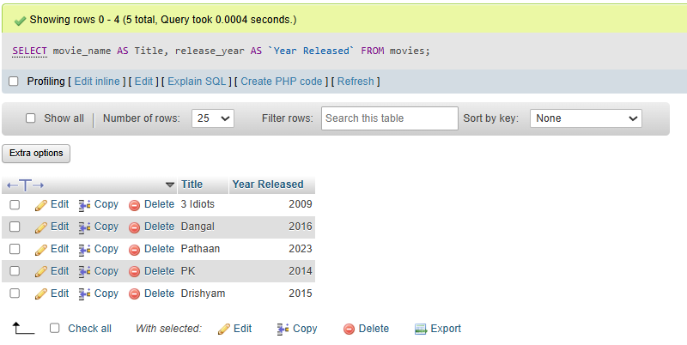

Tasks_04
CREATE DATABASE analytics_db
CREATE TABLE products (
product_id INT PRIMARY KEY AUTO_INCREMENT,
product_name VARCHAR(100),
price DECIMAL(10,2),
category VARCHAR(50)
);
INSERT INTO products (product_name, price, category)
VALUES
('Wireless Mouse', 599.00, 'Electronics'),
('Mechanical Keyboard', 2499.00, 'Electronics'),
('Laptop Backpack', 1299.00, 'Accessories'),
('Smart Watch', 2999.00, 'Wearables'),
('Running Shoes', 2499.00, 'Footwear');
-- This query selects all columns from the products table
SELECT * FROM products;

Output
